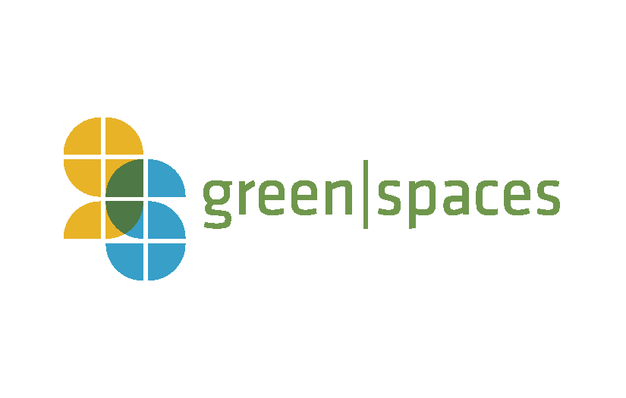
Lunch & Learn Sponsorship

green|spaces launched a monthly lunch and learn series to increase the awareness and promote products and technologies to further the practices of sustainability in the work and home lives of Chattanooga.

Topics vary from the future of EV’s, sustainable development, creating resilient communities and general overview of renewable energy sources.

Sponsoring Lunch & Learns provides an opportunity to highlight their company to local businesses, contractors, developers, architects and the general public.

Lunch & Learn Sponsorship: $250
• Logo with link on event promotions via facebook, twitter, website and e-newsletter with over 4000 subscribers
• Able to provide brochures or other material handouts at lunch & learn
• 3 - 5 minutes to speak about your company at lunch & learn
• 2 free passes to lunch & learn

Lunch & Learns take place on the 2nd Wednesday of the Month.

For questions or to apply to be a sponsor, please contact: Madison Rollings at Madison@greenspaceschattanooga.org or 423-648-0963

